 | National University  of Computer and Emerging Sciences  Chiniot-Faisalabad Campus  Department of Artificial Intelligence and Data Science | 
Course Code | AI4002
Course Title | Computer Vision – Lab
Lab Task | 1
Due Date | 02 September 2025
Instructions:
- Rename this Word file as LT1_22F-3170
- If found plagiarism, straight zero will be marked against task.
- Submit task on Due Date. No Late Submission will be Tolerated.

Question 1
Write a python code that traverse a 2D Matrix. Multiply even number by 10 and odd number by 7. Print the Output in a Matrix form.
Code
def updated_matrix(matrix):
rows = len(matrix)
cols = len(matrix[0])

result = []

for i in range(rows):
new_row = []
for j in range(cols):
num = matrix[i][j]
if num % 2 == 0:
new_row.append(num * 10)
else:
new_row.append(num * 7)
result.append(new_row)

return result

matrix = [
[1, 2, 3],
[4, 5, 6],
[7, 8, 9]
]

modified = updated_matrix(matrix)

print("--------------This is Original Matrix:-------------------")
for row in matrix:
print(row)

print("\n--------------This is Modified Matrix:-------------------")
for row in modified:
print(row)

Screenshot
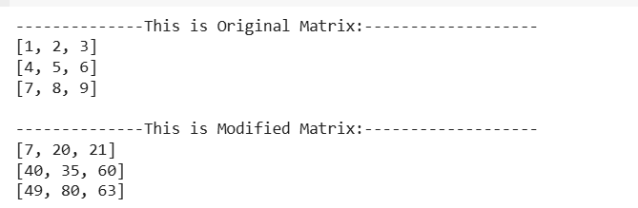

Question 2
Write a python code that divide image into Red, Green, Blue channels and merge as Green, Blue, Red channels to make a new image. GBR means Green will be first channel, Blue will be second and Red will be the third one.
Code
import cv2
import matplotlib.pyplot as plt

image = cv2.imread('cv_image.png')

b, g, r = cv2.split(image)

gbr_image = cv2.merge([g, b, r])

image_rgb = cv2.cvtColor(image, cv2.COLOR_BGR2RGB)
gbr_rgb = cv2.cvtColor(gbr_image, cv2.COLOR_BGR2RGB)

plt.figure(figsize=(10,5))

plt.subplot(1,2,1)
plt.imshow(image_rgb)
plt.title("Original Image")
plt.axis("off")

plt.subplot(1,2,2)
plt.imshow(gbr_rgb)
plt.title("GBR Image")
plt.axis("off")

plt.show()

Screenshot
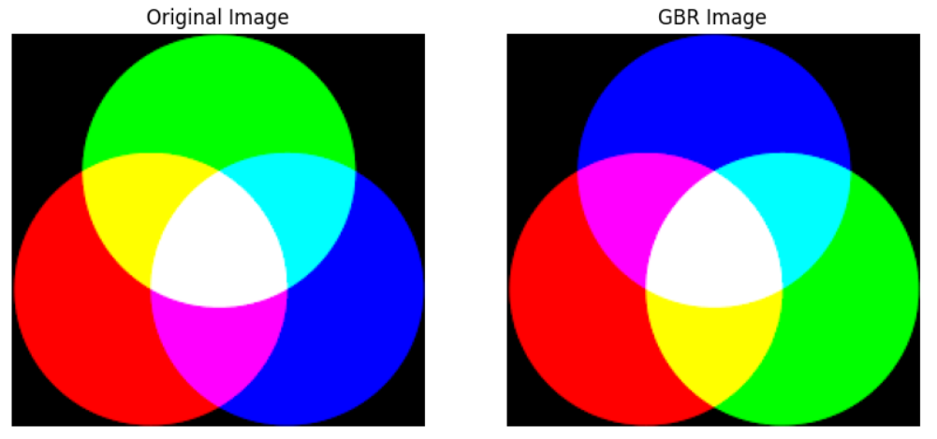

Question 3
Write a python code to traverse an image and inverse its pixel intensity to make a resultant image aka negative image. And show both images side by side (1 by 2).
Hint: (Out = 255 – In)
Code
import cv2
import matplotlib.pyplot as plt

image = cv2.imread('new.png')

negative_image = 255 - image

image_rgb = cv2.cvtColor(image, cv2.COLOR_BGR2RGB)
negative_rgb = cv2.cvtColor(negative_image, cv2.COLOR_BGR2RGB)

plt.figure(figsize=(10,5))

plt.subplot(1,2,1)
plt.imshow(image_rgb)
plt.title("Original Image")
plt.axis("off")

plt.subplot(1,2,2)
plt.imshow(negative_rgb)
plt.title("Negative Image")
plt.axis("off")

plt.show()

Screenshot
